Harold Vance Department of Petroleum Engineering

Texas A&M University

Petroleum Engineering 201S

Introduction to Petroleum Engineering

Notes on Dimensions and Units

Spring 2002

Fluid Properties

1. Liquid Specific Gravity

$γ_{\text{liquid}} = \frac{ρ_{\text{liquid}}}{ρ_{\text{water}}}$

2. API Gravity

°$\text{API} = \frac{\text{141}\text{.}5}{γ_{\text{liquid}}} − \text{131}\text{.}5$

3. Gas Specific Gravity

$γ_{\text{gas} } = \frac{ρ_{\text{gas}}}{ρ_{\text{air}}} = \frac{M_{g}}{M_{\text{air}}} = \frac{M_{g(\text{pure} \text{gas})}}{\text{28}\text{.}\text{97}} = \frac{M_{\text{apparent}( \text{gas} \text{mixture})}}{\text{28}\text{.}\text{97}}$

- Gas in Solution

R_{s} = standard cubic feet of gas liberated when one stock tank barrel of crude oil is

produced

5. Oil Formation Volume Factor

B = $\frac{\text{volume} \text{occupied} \text{at} \text{reservoir} \text{pressure} \text{and} \text{temperature}}{\text{volume} \text{occupied} \text{at} \text{standard} \text{pressure} \text{and} \text{temperature}}$

B= . In other words:

B= $\left(\frac{\text{RB}}{\text{STB}}\right)$

= $\frac{\frac{\text{mass} \text{of} \text{oil}}{\text{STB}}+\frac{\text{mass} \text{of} \text{gas}}{\text{STB}}}{\frac{\text{mass} \text{of} \text{reservoir} \text{liquid}}{\text{RB}}}$= $\frac{ρ_{\text{STO}}+0\text{.}\text{01357}R_{s}γ_{g}}{ρ_{\text{oR}}}$,

where: ρand ρare densities of the stock tank oil and reservoir liquid, both in
lb_{m}/ft³, and 0.01357 converts the gas volume to mass.

The conversion factors is derived as follows:

R${}_{s}\left(\frac{\text{Scf}}{\text{STB}}\right)\left(\frac{\text{lb}⋅\text{mole}}{\text{380}\text{.}7 \text{Scf}}\right)\left(\frac{\text{28}\text{.}\text{97}γ_{g}{\text{lb}}_{m}}{\text{lb}⋅\text{mole}}\right)\left(\frac{\text{STB}}{5\text{.}\text{615}{\text{ft}}^{3}}\right)$= 0.01357Rγ${}_{g}\frac{{\text{lb}}_{m}}{{\text{ft}}^{3}}$.
Example Fluid Properties Calculations

1. Liquid Specific Gravity

Given

Density of Liquid 48.6 lb_{m}/ft³
Density of Water 62.4 lb_{m}/ft³

Definition
$γ_{\text{liquid}} = \frac{ρ_{\text{liquid}}}{ρ_{\text{water}}}$

Calculation
$γ_{\text{liquid}} = \frac{ρ_{\text{liquid}}}{ρ_{\text{water}}}=\frac{\text{48}\text{.}6}{\text{62}\text{.}4}=0\text{.}\text{779}$

2. API Gravity

Given

Specific gravity of liquid-1 0.779
Specific gravity of liquid-2 0.876
Specific gravity of liquid-3 1.000

Definition
°$\text{API} = \frac{\text{141}\text{.}5}{γ_{\text{liquid}}} − \text{131}\text{.}5$
Calculations

Specific Gravity API Gravity
0.779 50.0
0.876 30.0
1.000 10.0

3. Gas Gravity

Given Component Composition (Mole fraction)

Methane C1 0.850
Ethane C2 0.090
Propane C3 0.040
n-Butane n-C4 0.020

Definition
$γ_{\text{gas} } = \frac{ρ_{\text{gas}}}{ρ_{\text{air}}} = \frac{M_{g}}{M_{\text{air}}} = \frac{M_{g(\text{pure} \text{gas})}}{\text{28}\text{.}\text{97}} = \frac{M_{\text{apparent}( \text{gas} \text{mixture})}}{\text{28}\text{.}\text{97}}$
3. Gas Gravity (continued)

Calculation

Component | Mole fraction | Molar Mass | Component Mass | Mass fraction
j | y${}_{j}$ | M${}_{j}$ | $$y_{j}M_{j}$$ | $$y_{j}{M_{j}}/{\text{19}}\text{.}\text{26}$$
C1 | 0.850 | 16.04 | 13.63 | 0.708
C2 | 0.090 | 30.07 | 2.71 | 0.141
C3 | 0.040 | 44.10 | 1.76 | 0.091
n-C4 | 0.020 | 58.12 | 1.16 | 0.060
 | 1.000 |  | 19.26 | 1.000

$$γ_{\text{gas} } = \frac{M_{\text{apparent}( \text{gas} \text{mixture})}}{\text{28}\text{.}\text{97}} \frac{\text{19}\text{.}\text{26}}{\text{28}\text{.}\text{97}}=0\text{.}\text{665}$$

4. Oil Formation Volume Factor

Given

Density of Reservoir Oil 47.5 lb_{m}/ft³
Density of Stock Tank Oil 55.5 lb_{m}/ft³
Gas in Solution 400 Scf/STB
Gas Gravity 0.72

Definition
B_{o} = $\frac{ρ_{\text{STO}}+0\text{.}\text{01357}R_{s}γ_{g}}{ρ_{\text{oR}}}$
Calculation
B_{o} = $\frac{\text{55}\text{.}5+(0\text{.}\text{01357})(\text{400})(0\text{.}\text{72})}{\text{47}\text{.}5}=1\text{.}\text{251} \frac{\text{RB}}{\text{STB}}$

5. Gas Formation Volume Factor

Given

Reservoir Pressure 1000 psi Standard Pressure 14.65 psi
Reservoir Temperature 610 ºR Standard Temperature 60 ºF
Gas Law Deviation Factor (z) 0.90

Definition
B_{g} = $\frac{V_{\text{rc}}}{V_{\text{sc}}}$

Calculation
B_{g} = $\frac{V_{\text{rc}}}{V_{\text{sc}}}=\frac{{\left({\text{nzRT}}/p\right)}_{\text{rc}}}{{\left({\text{nRT}}/p\right)}_{\text{sc}}}=\frac{(0\text{.}9)(\text{610})(\text{14}\text{.}\text{65})}{(\text{60}+\text{460})(\text{1000})}=0\text{.}\text{0155}\frac{\text{Rcf}}{\text{Scf}}=0\text{.}\text{00275}\frac{\text{RB}}{\text{Scf}}$
Fluid Properties Nomenclature

Lower Case Letters
n Amount, moles
n_{rc} Amount at reservoir conditions, moles
n_{sc} Amount at surface conditions, moles
p Pressure, FL⁻²
p_{rc} Pressure at reservoir conditions, FL⁻² (psia)
p_{sc} Pressure at surface conditions, FL⁻² (psia)
z Gas law deviation factor, actual volume/ideal volume
z_{rc} Gas law deviation factor at reservoir conditions, actual volume/ideal volume
z_{sc} Gas law deviation factor at surface conditions, actual volume/ideal volume (1.0)

Upper Case Letters
B Formation volume factor, reservoir volume/surface volume
B_{g} Gas formation volume factor, reservoir volume/surface volume (rcf/scf)
B_{o} Oil formation volume factor, reservoir volume/surface volume (rb/stb)
B_{w} Water formation volume factor, reservoir volume/surface volume (rb/stb)
M Molar mass, mass/mole
M_{a} Apparent molar mass of a gas mixture, mass/mole (lb_{m}/lb·mole)
M_{air} Molar mass of air, mass/mole (28.97 lbm/lb·mole)
M_{g} Molar mass of gas, mass/mole (lbm/lb·mole)
R Gas-oil ratio, surface gas volume/surface oil volume
R_{p} Produced gas-oil ratio, surface gas volume/surface oil volume (scf/stb)
R_{s} Solution gas-oil ratio, surface gas volume/surface oil volume (scf/stb)
T Temperature
V Volume, L³
V_{rc} Volume at reservoir conditions, L³ (ft³)
V_{sc} Volume at surface conditions, L³ (ft³)

Greek Letters
γ_{l} Liquid specific gravity, density of liquid at 60ºF/density of water at 60ºF
ρ Mass density, mass/volume
ρ_{g} Density, mass/volume (lb_{m}/ft³)
ρ_{l} Liquid density, mass/volume (lb_{m}/ft³)
ρ_{o} Oil density, mass/volume (lb_{m}/ft³)
ρ_{oR} Oil density at reservoir conditions, mass/volume (lb_{m}/ft³)
ρ_{STO} Oil density at surface (stock tank) conditions, mass/volume (lb_{m}/ft³)
ρ_{w} Water density, mass/volume (lb_{m}/ft³)
Dimension and Unit Systems

Dimensions are physical quantities and units are standards of measurement. Thus, dimensions are independent of units.

Dimensions are classified as fundamental, supplementary, and derived. Supplementary dimensions can be considered as fundamental dimensions. Fundamental dimensions are those necessary to describe a particular field of engineering or science. Derived dimensions are combinations of fundamental dimensions. A dimensional system is just the smallest number of fundamental dimensions to form a consistent and complete set for a field of engineering or science. A dimensional system is called an absolute system if its dimensions are not affected by gravity; otherwise it is called a gravitational system.

Units are classified as base, supplementary, and derived. Units for supplementary dimensions can also be considered as base units. Derived units are combinations of base units.

A dimension and unit system is a set of fundamental dimensions and base units necessary for a particular field of science or engineering. It is called a coherent system if equations between numerical values (units) have the same form as the corresponding equations between the quantities (dimensions). For example, in the SI system, F = m·a is used to define the derived dimension. Likewise, 1 newton = (1 kilogram)·(1 meter per second squared) is used to define the derived unit. In other words, in a coherent system, combinations of any two unit quantities is the unit of the resulting quantity. Coherency is a major advantage of the SI system.

In petroleum engineering, three dimension and unit systems are commonly used:

- The International System of Units (SI Units)
- The American Engineering System of Units (Oilfield Units)
- The Darcy System of Units (Darcy Units)

The purpose of these notes is to help you learn the above systems and how to convert units from one system to another.

The International System of Units (SI)

Fundamental Dimension | Base Unit
length [L] | meter (m)
mass [M] | kilogram (kg)
time [t] | second (s)
electric current [I] | ampere (A)
absolute temperature [T] | kelvin (K)
luminous intensity [l] | candela (cd)
amount of substance [n] | mole (mol)

Supplementary Dimension | Base Unit
plane angle [θ] | radian (rad)
solid angle [ω] | steradian (sr)

Derived Dimension | Unit | Definition
acceleration [L/t²] | meter per second squared | m/s²
area [L²] | square meter | m²
Celsius temperature [T ] | degree Celsius (ºC) | K
concentration [n/L³] | mole per cubic meter | mol/m³
density [M/L³] | kilogram per cubic meter | kg/m³
electric charge [It] | coulomb (C) | A·s
electric potential [ML²/It³] | volt (V) | W/A
electric resistance [ML²/I²t³] | ohm (Ω) | V/A
energy [ML²/t²] | joule (J) | N·m
force [ML/t²] | newton (N) | kg·m/s²
frequency [1/t] | hertz (Hz) | 1/s
molar mass [M/n ] | kilogram per mole | kg/mol
power [ML²/t³] | watt (W) | J/s
pressure [M/Lt²] | pascal (Pa) | N/m²
quantity of heat [ML²/t²] | joule (J) | N·m
specific heat [L²/t²T] | joule per kilogram kelvin | J/(kg·K)
thermal conductivity [ML/t³T] | watt per meter kelvin | W/(m·K)
velocity [L/t] | meter per second | m/s
viscosity, dynamic [M/Lt] | pascal second | Pa·s
volume [L³] | cubic meter | m³
work [ML²/t²] | joule (J) | N·m
The International System of Units (SI) (Cont'd)

Prefix | Decimal Multiplier | Symbol
atto | 10⁻¹⁸ | a
femto | 10⁻¹⁵ | f
pico | 10⁻¹² | p
nano | 10⁻⁹ | n
micro | 10⁻⁶ | μ
milli | 10⁻³ | m
centi | 10⁻² | c
deci | 10⁻¹ | d
deka | 10⁺¹ | da
hecto | 10⁺² | h
kilo | 10⁺³ | k
mega | 10⁺⁶ | M
giga | 10⁺⁹ | G
tera | 10⁺¹² | T
peta | 10⁺¹⁵ | P
exa | 10⁺¹⁸ | E

American Engineering System of Units (AES)

Fundamental Dimension | Base Unit
length [L] | foot (ft)
mass [M] | pound mass (lb_{m})
force [F] | pound force (lb_{f})
time [t] | second (sec)
electric charge[Q] | coulomb (C)
absolute temperature [T] | Rankine (ºR)
luminous intensity [l] | candela (cd)
amount of substance [n] | mole (mol)

Supplementary Dimension | Base Unit
plane angle [θ] | radian (rad)
solid angle [ω] | steradian (sr)

Derived Dimension | Unit | Definition
acceleration [L/t²] | foot per second squared | ft/sec²
area [L²] | square foot | ft²
Fahrenheit temperature [T ] | degree Fahrenheit (ºF) | ºR-459.67
concentration [n/L³] | mole per cubic foot | mol/ft³
density [M/L³] | pound mass per cubic foot | lb_{m}/ft³
electric current [Q/t] | ampere (A) | C/sec
electric potential [FL/Q] | volt (V) | W/A
electric resistance [FLt/Q²] | ohm (Ω) | V/A
energy [FL] | foot pound force | ft· lb_{f}
frequency [1/t] | hertz (Hz) | 1/sec
molar mass [M/n ] | pound mass per mole | lb_{m}/mol
power [FL/t] | foot pound force per second | ft· lb_{f}/sec
pressure [F/L²] | pound force per square foot (psf) | lb_{f}/ft²
quantity of heat [FL] | british thermal unit (BTU) | 777.65 ft· lb_{f}
velocity [L/t] | foot per second | ft/sec
viscosity, dynamic [Ft/L²] | pound force second per square foot | lb_{f}·sec/ft²
volume [L³] | cubic foot | ft³
work [FL] | foot pound force | ft· lb_{f}
Oilfield Units (related to AES System)

Dimension | Unit | Definition
area [L²] | acre (ac) | 43,560 ft²
energy [FL] | horsepower hour (hp·hr)  kilowatt hour (kW·hr) | 1.98000 x 10⁶ ft· lb_{f}  2.6552 x 10⁶ ft· lb_{f}
length [L] | inch (in)  yard (yd)  mile (mi) | 1/12 ft  3 ft  5,280 ft
mass [M] | ounce (oz)  ton | 1/16 lb_{m}  2000 lb_{m}
power [FL/t] | horsepower (hp)  watt (W) | 550 ft· lb_{f}/sec  0.73756 ft· lb_{f}/sec
pressure [F/L²] | pound force per square inch (psi)  atmosphere (atm) | 144 lb_{f}/ft²  14.696 psi
time [t] | minute (min)  hour (hr)  day | 60 sec  3,600 sec  86,400 sec
viscosity, dynamic [Ft/L²] | centipoise (cp) | 10⁻² dyne·s/cm²
volume [L³] | gallon (gal)  barrel (bbl)  acre·ft (ac·ft) | 0.133681 ft³  5.614583 ft³  43,560 ft³

Conversion of Units

In a coherent system of units such as SI, a derived dimension is a product or quotient of other dimensions. For example, the dimension—force—is the product of mass and acceleration, F = ma, and the unit of force—newton—is the product of the unit of mass and the unit of acceleration. In the American Engineering System, force is expressed in lb_{f}, mass in lb_{m}, and acceleration in ft/sec². This system is obviously not coherent. Hence, a conversion factor other than one must be used in the equation; that is, F = $\frac{\text{ma}}{g_{c}}$, where g_{c} = 32.174$\frac{{\text{lb}}_{m}⋅\text{ft}}{{\text{sec}}^{2}⋅{\text{lb}}_{f}}$is a constant, known as the gravitational conversion constant.

Derivation of g_{c}

The principle of conservation of units is used to derive g_{c}. Briefly stated, this principle is that to convert a relationship (an equation) from a given system of units to another (a required) system of units, the given units must be conserved. The technique is illustrated below.

We wish to convert F = ma from SI to AES. Here, SI is the given system and AES is the required system.

First, find the dimension of the “hidden constant” in the given equation. In other words,

1 = $\frac{F}{\text{ma}}$ has dimension force divided by the product of mass and acceleration.

Next, consider the units of the hidden constant—the given units are

$\frac{N⋅s^{2}}{\text{kg}⋅m}$ and the required units are$\frac{{lb}_{f}⋅{\text{sec}}^{2}}{{\text{lb}}_{m}⋅ft}$.

Now, convert the given units of the hidden constant to the required units.

Thus,

$\left(\frac{\text{1 N}⋅s^{2}}{\text{kg}⋅m}\right)\left(\frac{0\text{.}\text{45359} \text{kg}}{{\text{lb}}_{m}}\right)\left(\frac{0\text{.}\text{3048} m}{\text{ft}}\right)\left(\frac{{\text{lb}}_{f}}{4\text{.}\text{4482 N}}\right)$= $\frac{1}{\text{32}\text{.}\text{174}}\frac{{lb}_{f}⋅{\text{sec}}^{2}}{{\text{lb}}_{m}⋅ft}$
Review Problems

1. A weir is a regular obstruction in an open flow channel over which flow takes place such as that shown in the sketch at right. It can be used to measure open channel flow rates. For a rectangular weir, the theoretical formula for the flow rate is

Q = 5.35LH^{1.5}

where Q is discharge rate in ft³/sec,
L is length of the weir in ft,
H is height of fluid above the crest in ft.

Determine a new constant so the formula can be applied with Q in m³/s and L and H in m.

2. The ideal gas equation can be written,

pv = RT

where p = pressure, Pa
v = molar volume, m³/(kg·mol)
R = gas constant, 8314.5 Pa·m³/(kg·mol·K)
T = absolute temperature, K

Determine a new constant so that the equation can be applied with p in lb_{f}/in², v in ft³/(lb_{m}·mol), and T in ºR.

3. The universal law of gravity may be written,

$$F=\left(6\text{.}\text{672} x {\text{10}}^{\text{-11}}\right)\frac{m_{1}m_{2}}{r^{2}}$$

where F = force of attraction between two bodies, N
m₁ = mass of body one, kg
m₂ = mass of body two, kg
r = distance between bodies, m

Determine a new constant so that the law can be applied with F in lb_{f}, m₁ & m₂ in lb_{m}, and r in mi.

Answers
1. 2.95 m^{0.5}/s
2. 10.732 psi· ft³/(lb_{m}·mol· ºR)
3. 1.192 x 10⁻¹⁸ lb_{f}·mi²/lb_{m}²

Porosity, Permeability, and Saturation (φ-k-S)

Porosity is a measure of the fluid storage capacity of a rock,

$φ=\frac{V_{p}}{V_{b}}$

where φ = porosity, fraction
V_{b} = bulk volume = V_{p} + V_{m}
V_{p} = pore volume
V_{m} = matrix volume
Permeability is a measure of the fluid conductivity of a rock. It is defined by Darcy’s law, which is based upon ex-perimental data. For horizontal, linear flow of a liquid completely saturating the rock,  $k=\frac{qμL}{AΔp}$  where k = permeability, d  q = flow rate, cm³/s  μ = fluid viscosity, cp  L = length of flow path, cm  A = cross-sectional area of  flow path, cm²  Δp = pressure difference across  flow path, atm  The dimension of permeability is [L²].  $\left[\frac{qμL}{AΔp}\right]=\left[\frac{L^{3}}{t}⋅\frac{P⋅t}{1}⋅\frac{L}{1}⋅\frac{1}{L^{2}}⋅\frac{1}{P}\right]$ | 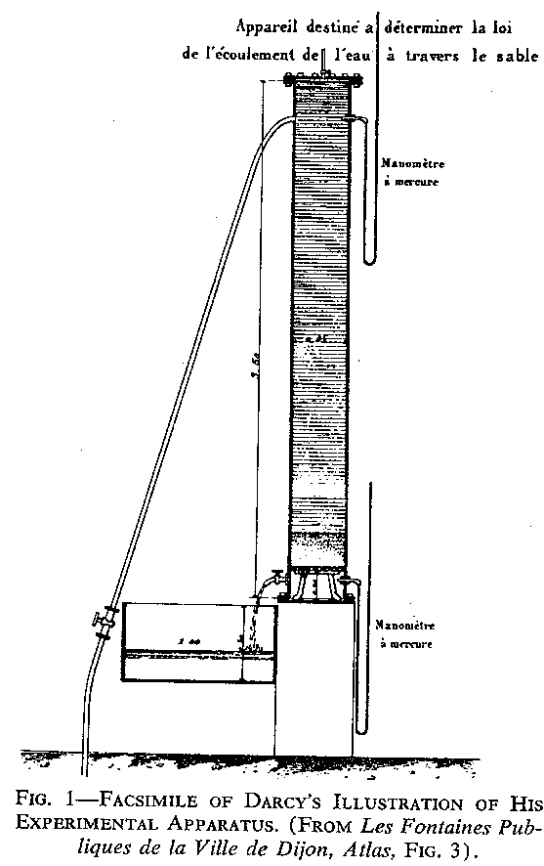

Saturation is a measure the amount and type of fluid stored in a rock.

$S_{ℓ}=\frac{V_{ℓ}}{V_{p}}$

where $S_{ℓ}$= saturation of fluid $ℓ$ (oil, water, or gas)
$V_{ℓ}$ = fluid volume ($ℓ$= oil, water, or gas)
V_{p} = pore volume
Darcy’s Law

Darcy found that when water flows vertically downward through sand, the volume of water passing through the system in unit time (the discharge q in Fig. 2) is proportional to the drop in head h across the sand. Considering the cross sectional area A and thick-ness of the sand l, these observations can be written,  $v=\frac{q}{A}=−K\frac{\text{dh}}{\text{dl}}$  where K is a coefficient depending upon the permeability of the sand and the properties of the fluid.  Darcy’s original experiment has been extended to answer questions about flow of different fluids in porous media of various permeabilities along flow paths in various directions. | 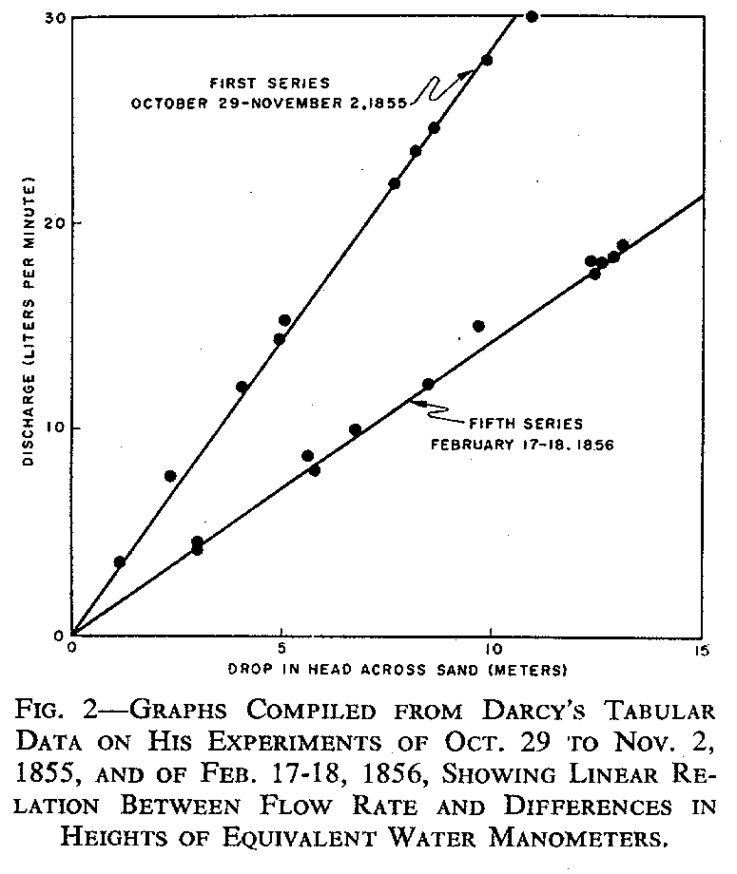

The generalized two dimensional form of Darcy’s law (API Code 27) is

$$v_{s}=−\frac{k}{μ}\left(\frac{\text{dp}}{\text{ds}}−\frac{ρg}{1\text{.}\text{01325}}\frac{\text{dz}}{\text{ds}}x {\text{10}}^{−6}\right)$$

where s = distance in direction of flow (always positive), cm
v_{s} = volume flux across a unit area of the porous medium in unit time (q/A)
along flow path s, cm/s
z = vertical coordinate (positive downward), cm
ρ = density of the fluid, g/cm³
g = acceleration of gravity, 980.665 cm/s²
dp/ds = pressure gradient along path s at the point to which v_{s} refers, atm/cm
μ = viscosity of the fluid, cp
k = permeability of the porous medium, d
The Darcy System of Units

Fundamental Dimension | Base Unit
length [L] | centimeter (cm)
mass [M] | gram (g)
time [t] | second (s)

Derived Dimension | Unit | Definition
acceleration [L/t²] | centimeter per second squared | cm/s²
area [L²] | square centimeter | cm²
density [M/L³] | gram per cubic centimeter | g/cm³
energy [ML²/t²] | erg | dyne·cm
force [ML/t²] | dyne | g·cm/s²
permeability [L²] | darcy (d) | cp·cm²/atm·s
pressure [M/Lt²] | atmosphere (atm) | 1.013250 x 10⁶ dyne/cm²
velocity [L/t] | centimeter per second | cm/s
viscosity, dynamic [M/Lt] | centipoise (cp) | 10⁻² dyne·s/cm²
volume [L³] | cubic centimeter | cm³
work [ML²/t²] | erg | dyne·cm

In SI Units

Derived Dimension | Unit
permeability [L²] | square meter (m²)

In Oilfield Units

Derived Dimension | Unit
permeability [L²] | millidarcy (md)
Converting Permeability Units

The principle of conservation of units is used. Briefly stated, this principle is that to convert a relationship (an equation) from a given system of units to another (a required) system of units, the given units must be conserved. The technique is illustrated below.

We wish to convert $k=\frac{qμL}{AΔp}$ from Darcy units (d, cm, s, cp, atm) to Oilfield units (md, ft, bbl, day, cp, psi). Here, Darcy units is the given system and Oilfield units is the required system.

First, find the dimension of the “hidden constant” in the given equation. In other words,
1 = $\frac{\text{kA}Δp}{qμL}$ has dimension kAΔp divided by qμL [1].
Next, consider the units of the hidden constant—the given units are
$\frac{d⋅\text{atm}⋅s}{cp⋅{cm}^{2}}$ and the required units are$\frac{\text{md}⋅\text{ft}⋅\text{psi}⋅d\text{ay}}{\text{cp}⋅\text{bbl}}$.
Now, convert the given units of the hidden constant to the required units.

Thus,

$\left(\frac{\text{1 d}⋅\text{atm}⋅s}{cp⋅{cm}^{2}}\right)\left(\frac{{\text{10}}^{3}\text{md}}{d}\right)\left(\frac{\text{ft}}{\text{ft}}\right)\left(\frac{14\text{.}\text{696} \text{psi}}{\text{atm}}\right)\left(\frac{\text{day}}{\text{86,400} s}\right)\left(\frac{{\left(\text{30}\text{.}\text{48}\right)}^{2}{cm}^{2}}{{\text{ft}}^{2}}\right)$=

$$\left(\frac{\text{158}\text{.}\text{02} \text{md}⋅\text{ft}⋅\text{psi}⋅\text{day}}{cp⋅{\text{ft}}^{3}}\right)\left(\frac{5\text{.}\text{614583} {\text{ft}}^{3}}{\text{bbl}}\right)=\frac{\text{887}\text{.}\text{22} \text{md}⋅\text{ft}⋅\text{psi}⋅\text{day}}{cp⋅b\text{bl}}$$

Converting from Darcy units to other systems of units is similar.

Summary of Darcy equations for horizontal, linear flow (including conversion factors):

Darcy Units | SI Units | Oilfield Units
$$k=\frac{qμL}{AΔp}$$ | $$k=\frac{qμL}{AΔp}$$ | $$k=\text{887}\text{.}2\frac{qμL}{AΔp}$$

NOTE: A m² is a huge permeability unit! There are 1.01325 x 10¹² d/m².
Thus, the SPE preferred SI unit for permeability is a μm², introducing
a factor of 10¹² in the equation.

Horizontal, Linear Flow

A
q q

L

x₁ x₂

Applying Darcy’s law,

$$v_{x}=\frac{q}{A}=−\frac{k}{μ}\frac{\text{dp}}{\text{dx}}$$

Separate the variables and integrate to obtain the flow equation,

$$q\int_{x_{1}}^{x_{2}}{\text{dx}}=−\frac{\text{kA}}{μ}\int_{p_{1}}^{p_{2}}{\text{dp}} ⇒ q({{\text{cm}}^{3}}/s)=−\frac{\text{kA}\left(p_{2}−p_{1}\right)}{μ\left(x_{2}−x_{1}\right)}=\frac{\text{kA}\left(p_{1}−p_{2}\right)}{μ\left(x_{2}−x_{1}\right)}=\frac{\text{kA}Δp}{μL}$$

In oilfield units, the equation is

$$q({\text{RB}}/{\text{day}})=\frac{1\text{.}\text{1271} x {\text{10}}^{−3}\text{kA}Δp}{μL} \text{or} q({\text{STB}}/{\text{day}})=\frac{1\text{.}\text{1271} x {\text{10}}^{−3}\text{kA}Δp}{μ\text{BL}}$$

EXAMPLE: A rock sample10 cm long and 2 cm² in cross section is used for some steady-state
flow tests. Calculate the permeability of the rock if it is completely saturated with
an oil having a viscosity of 2.5 cp and oil is flowed through the rock at a rate of
0.0080 cm³/s under a 1.5 atm pressure drop?

$$k=\frac{qμL}{AΔp}=\frac{\left(0\text{.}\text{0080} {{\text{cm}}^{3}}/s\right)\left(2\text{.}5 \text{cp}\right)\left(\text{10} \text{cm}\right)}{\left(2 {\text{cm}}^{2}\right)\left(1\text{.}5 \text{atm}\right)}=0\text{.}\text{067} d=\text{67} \text{md}$$
Wellbore Volumes

Wellbores are right circular cylinders,
the volume of which is,

$V={πr}^{2}h=\frac{π}{4}d^{2}h$ h

Many drilling and completion applications
require the annular volume,

$$V=π\left(r_{2}^{2}−r_{1}^{2}\right)h=\frac{π}{4}\left(d_{2}^{2}−d_{1}^{2}\right)h$$

EXAMPLE: Suppose you are the drilling engineer on a rig. You have set 7-5/8 inch OD,
33.7 lb_{m}/ft casing (ID = 6.765 inches) from 0 to 5900 ft and have drilled out to
7900 ft. The average bore hole diameter from 5900 to 7900 ft is 6.25 inches.
Calculate the annular volume in ft³ if 4-1/2 inch OD casing is installed.
$V=\frac{π}{4}\left\{\left[{\left(\frac{6\text{.}\text{765} \text{in}}{\text{12} {\text{in}}/{\text{ft}}}\right)}^{2}−{\left(\frac{4\text{.}5 \text{in}}{\text{12} {\text{in}}/{\text{ft}}}\right)}^{2}\right]\text{5900} \text{ft}+\left[{\left(\frac{6\text{.}\text{25} \text{in}}{\text{12} {\text{in}}/{\text{ft}}}\right)}^{2}−{\left(\frac{4\text{.}5 \text{in}}{\text{12} {\text{in}}/{\text{ft}}}\right)}^{2}\right]\text{2000} \text{ft}\right\}$

V = 987 ft³
Pressure Gradients

The basic equation of hydrostatics can be written

Δp = ρgΔh

where Δp = change in fluid pressure, Pa
ρ = density, kg/m³
g = acceleration of gravity, m/s²
Δh = change in height of fluid, m

$\frac{Δp}{Δh}=ρg$The pressure gradient (Pa/m) is

There is no conversion factor in SI because

$\left[\frac{\text{Pa}}{m}=\frac{\text{kg}}{m^{3}}⋅\frac{m}{s^{2}}=\frac{N}{m^{2}}⋅\frac{1}{m}=\frac{\text{Pa}}{m}\right]$

In oilfield units, Δp = change in fluid pressure, lb_{f}/in² or psi
ρ = density, lb_{m}/ft³
g = acceleration of gravity, ft/s²
Δh = change in height of fluid, ft

and the pressure gradient (psi/ft) is

$\frac{Δp}{Δh}=\frac{ρg}{{\text{144g}}_{c}}, \text{where } g_{c}=\text{32}\text{.}\text{174}\frac{{\text{lb}}_{m}⋅\text{ft}}{{\text{lb}}_{f}⋅s^{2}}$

Notice that the units check because

$$\left[\frac{\text{psi}}{\text{ft}}=\frac{\text{lbm}}{{\text{ft}}^{3}}⋅\frac{\text{ft}}{s^{2}}⋅\frac{{\text{ft}}^{2}}{{\text{in}}^{2}}⋅\frac{{\text{lb}}_{f}⋅s^{2}}{{\text{lb}}_{f}⋅\text{ft}}=\frac{{\text{lb}}_{f}}{{\text{in}}^{2}}⋅\frac{1}{\text{ft}}=\frac{\text{psi}}{\text{ft}}\right]$$

EXAMPLE: Calculate the pressure gradient for a fluid having a density of 65 lb_{m}/ft³.
Assume g = 32 ft/s².

$\frac{Δp}{Δh}=\frac{ρg}{{\text{144g}}_{c}}=\frac{\left(\text{65}\right)\left(\text{32}\right)}{\left(\text{144}\right)\left(\text{32}\text{.}\text{174}\right)}=0\text{.}\text{449} \text{or} 0\text{.}\text{45} {\text{psi}}/{\text{ft}}$

Horizontal, Radial Flow

ds = -dr

r

h
r_{w} r_{e}

Applying Darcy’s law,

$$v_{r}=\frac{q}{A}=\frac{q}{2π\text{rh}}=\frac{k}{μ}\frac{\text{dp}}{\text{dr}}$$

Separate the variables and integrate to obtain the flow equation,

$$q\int_{r_{w}}^{r_{e}}{\frac{\text{dr}}{r}}=\frac{2π\text{kh}}{μ}\int_{p_{w}}^{p_{e}}{\text{dp}} ⇒ q({{\text{cm}}^{3}}/s)=\frac{2π\text{kh}\left(p_{e}−p_{w}\right)}{μ\text{ln}\left(r_{e}/r_{w}\right)}=\frac{2π\text{kh}Δp}{μ\text{ln}\left(r_{e}/r_{w}\right)}$$

In oilfield units, the equation for liquid is

$q_{ℓ}({\text{RB}}/{\text{day}})=\frac{7\text{.}\text{0819} x {\text{10}}^{−3}\text{kh}Δp}{μ\text{ln}\left(r_{e}/r_{w}\right)} \text{or} q_{ℓ}({\text{STB}}/{\text{day}})=\frac{7\text{.}\text{0819} x {\text{10}}^{−3}\text{kh}Δp}{{μB}_{ℓ}\text{ln}\left(r_{e}/r_{w}\right)}$
and, the equation for gas is

$q_{g}({\text{RB}}/{\text{day}})=\frac{7\text{.}\text{0819} x {\text{10}}^{−3}\text{kh}Δp}{μ\text{ln}\left(r_{e}/r_{w}\right)} \text{or} q_{g}({\text{Scf}}/{\text{day}})=\frac{7\text{.}\text{0819} x {\text{10}}^{−3}\text{kh}Δp}{{μB}_{g}\text{ln}\left(r_{e}/r_{w}\right)}$
Reservoir Volumes

h
r_{w} r_{e}

The volume occupied by the reservoir rock or bulk volume is
$$V_{b}={πr}_{e}^{2}h$$

Since porosity is the ratio of the pore volume to bulk volume, the pore volume is
$V_{p}={πr}_{e}^{2}hφ$

And, since water saturation is the fraction of the pore volume filled with water, the hydrocarbon pore volume is
$V_{\text{hc}}={πr}_{e}^{2}hφ\left(1−S_{w}\right)$

A commonly used equation to calculate the surface volume of oil in place is

$N(\text{STB})=\frac{\text{7758}\text{Ah}φ\left(1−S_{w}\right)}{B_{o}},\text{where} A \text{is} \text{the} \text{drainage} \text{area} \text{in} \text{acres}\text{.}$

and the surface volume of gas in place is

$G(\text{Scf})=\frac{\text{7758}\text{Ah}φ\left(1−S_{w}\right)}{B_{g}},\text{where} B_{g} \text{is} \text{the} \text{gas} \text{formation} \text{volume} \text{factor} \text{in} {\text{RB}}/{\text{Scf}}\text{.}$
Homework Problems

1. A certain oilfield has an average producing gas-oil ratio of 350 scf/stb. The density of the stock tank oil is 54.7 lb_{m}/ft³ at 60 ºF and the apparent molar mass of the associated gas is 21.7 lb_{m}/lb⋅mole. Determine the

a. API gravity of the stock tank oil.
b. Specific gravity of the associated gas.
c. Density of the reservoir oil if the oil formation volume factor is 1.2 rb/stb and the gas in
solution is equal to the average producing gas-oil ratio.
d. Type of reservoir fluid.

2. The equation of state for a particular substance at low pressures can be written

p = 53.55ρT,

where p = pressure, lb_{f}/ft²
ρ = density, lb_{m}/ft³
T = absolute temperature, ºR

a. Determine a new constant so the equation can be used with p in Pa, ρ in kg/m³, and T in K.
b. Use the ideal gas law (pV = nRT), the definition of quantity (mass/molar mass), and the
definition of density (mass/volume) to identify the substance.

3. Power is defined as work per unit time.

a. Find the units of the hidden constant in P = W/t (SI system), where P is power in
watts, W is work in newton-meters, and t is in seconds.
b. Convert to constant to the AES system, where P is power in horsepower, W is work in
foot-pounds of force, and t is in minutes.

4. A cylindrical sandstone sample, one inch in diameter and one inch long has a pore volume of 0.275 in³. The pores are partially filled with 0.135 in³ of water. What is the porosity and water saturation of the sample?

5. A cylindrical sandstone sample, one inch in diameter and one inch long is placed in a permeameter and water having a viscosity of one centipoise is flowed through the circular faces of the sample at a rate of one cm³/s under a pressure difference of one atmosphere. What is the permeability of the sample?

6. An acre-ft of reservoir has a bulk volume of 43,560 ft³. Calculate the volume of water (in barrels per acre-ft) for a sandstone reservoir having a porosity of 20 % and a water saturation of 25 %.

7. A rock sample is 1 inch long and 1 inch in diameter. The sample is used for some steady-state flow tests. Calculate the permeability of the rock if it is completely saturated with water having a viscosity of 1 cp and water is flowed through the sample at a rate of 0.5 in³/min and the pressure drop is 10 psi.

8. Find the conversion constant to calculate permeability in md from a horizontal, linear flow experiment when flow rate is in cm³/s, viscosity is in cp, length is in cm, and pressure drop is in dynes/cm².

9. Find the conversion constant to calculate permeability in md from a horizontal, linear flow experiment when flow rate is in m³/day, viscosity is in cp, length is in m, and pressure drop is in kPa.

10. Suppose you are the drilling engineer on a rig. You have set 9 5/8 in OD, 40 lb_{m}/ft casing (ID = 8.835 in) from 0 to 2000 ft and have drilled a 7 7/8 in bore hole from 2000 to 4000 ft.

a. Find the capacity of the hole in barrels from 0 to 4000 feet.
b. The hydrostatic pressure at 4000 ft with fresh water in hole.
c. The annular volume if 4.5 inch OD, 11.60 lb_{m}/ft casing is installed from 0 to 4000 ft
with fresh water in hole.

11. Find the conversion constant to calculate pressure gradient in psi/ft when fluid density is in lb_{m}/gal (ppg)

12. A vertical gas well is 6000 ft deep.

a. What is its bottom hole temperature if the mean surface temperature is 60 ºF and the
local temperature gradient is 1.1 ºF/100 ft?
b. What is its bottom hole flowing pressure if the surface flowing pressure is 900 psi
and the pressure gradient in the well bore is 0.15 psi/ft?

13. Assume a vertical well drains a right cylindrically shaped oil reservoir for which you have the following data:

drainage area 40 acres (external radius = 745 ft)
formation thickness 25 feet
radius of well bore 0.25 feet
porosity 19 %
water saturation 21 %
permeability 75 millidarcy
oil viscosity 2.1 centipoise
pressure at external radius 3545 psi
pressure at the well bore radius 1515 psi

Calculate the initial production rate in reservoir barrels per day.

14. Given the following data on a gas reservoir:

porosity 0.22
water saturation 0.30
gas formation volume factor 1.0 rb/MScf

a. Calculate the volume of gas in MScf per acre-foot of reservoir volume.
b. If the recovery factor is 80 %, what is the recoverable reserve of a 160 acre spaced well
with an average reservoir thickness of 15 feet?

Problem Layout
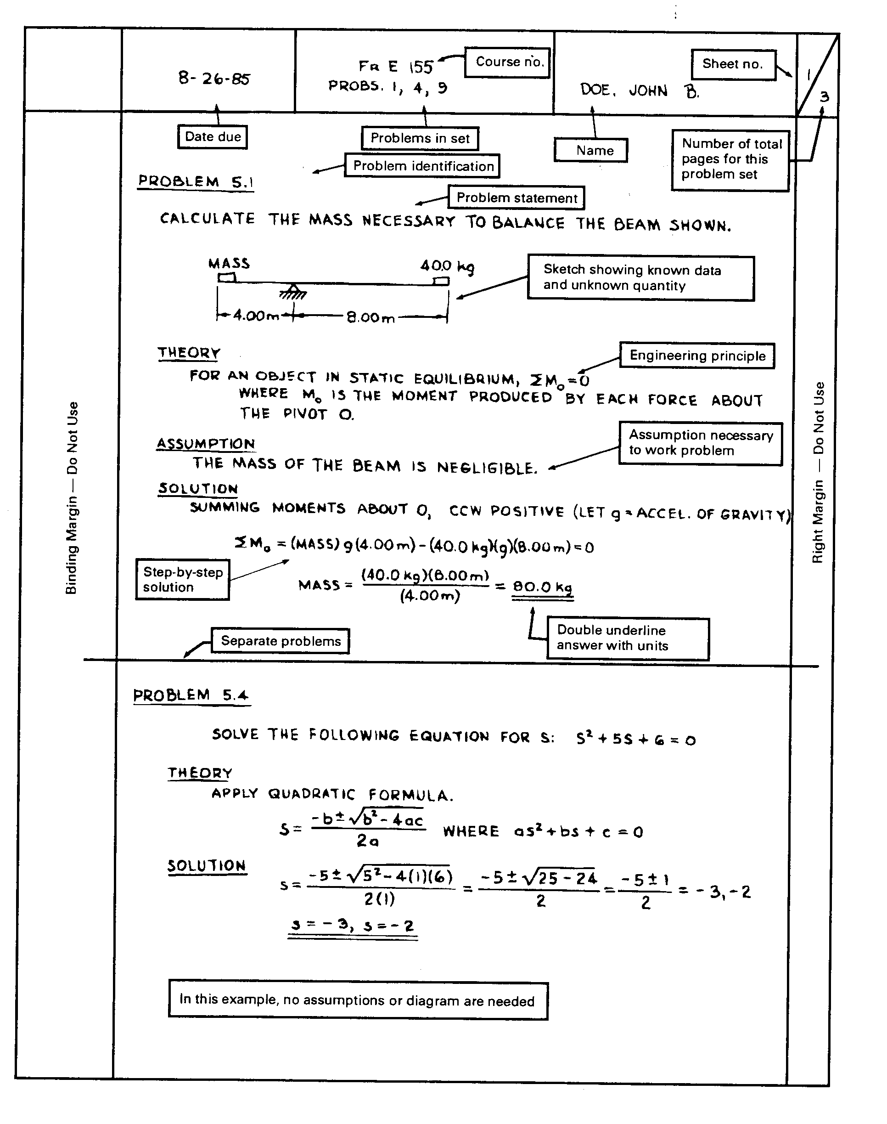
Conversion Factors

To convert from | Multiply by | To obtain
acres | 4.356 x 10⁴ | sq feet
acres | 4.047 x 10³ | sq meters
acre-feet | 4.356 x 10⁴ | cubic feet
atmospheres | 7.6 x 10¹ | cm of mercury at 0 ºC
atmospheres | 3.39 x 10¹ | ft of water at 4 ºC
atmospheres | 1.01325 x 10⁵ | pascals
atmospheres | 1.4696 x 10¹ | pounds-force/sq in
barrels(oil) | 5.614583 | cubic feet
barrels(oil) | 4.2 x 10¹ | gallons
barrels(oil)/d | 2.295 x 10⁻³ | cubic meters/s
Btu | 1.0550 x 10¹⁰ | ergs
Btu | 7.7816 x 10² | ft-pounds
Btu | 3.927 x 10⁻⁴ | horsepower-hours
Btu | 1.055 x 10³ | joules
Btu | 2.928 x 10⁻⁴ | kilowatt-hours
centimeters | 3.281 x 10⁻² | feet
centimeters | 3.937 x 10⁻¹ | inches
centimeters | 6.214 x 10⁻⁶ | miles
cm of mercury | 1.316 x 10⁻² | atmospheres
cm of mercury | 4.461 x 10⁻¹ | ft of water
cm of mercury | 1.333 x 10³ | pascals
cm of mercury | 1.934 x 10⁻¹ | pounds-force/sq in
cm/s | 1.969 | ft/min
cm/s | 3.281 x 10⁻¹ | ft/s
cm/s | 3.6 x 10⁻² | kilometers/h
cm/s | 2.237 x 10⁻² | miles/h
centipoise | 1.0 x 10⁻³ | pascal-seconds
cubic cm | 6.28982 x 10⁻⁶ | barrels(oil)
cubic cm | 3.531 x 10⁻⁵ | cubic ft
cubic cm | 2.642 x 10⁻⁴ | gallons
cubic cm | 1.0 x 10⁻³ | liters
cubic cm/s | 5.434 x 10⁻¹ | barrels(oil)/d
cubic feet | 1.781 x 10⁻¹ | barrels(oil)
cubic feet | 2.832 x 10⁻² | cubic meters
cubic feet | 7.48052 | gallons
cubic feet | 2.832 x 10¹ | liters
cubic ft/d | 3.278 x 10⁻⁷ | cubic meters/s
cubic feet/h | 4.275 | barrels(oil)/d
cubic feet/min | 4.720 x 10⁻¹ | liters/s
cubic feet/s | 4.48831 x 10² | gallons/min
cubic meters | 6.28982 | barrels(oil)
cubic meters | 3.531 x 10¹ | cubic ft
To convert from | Multiply by | To obtain
cubic meters | 2.642 x 10² | gallons
cubic meters | 1.0 x 10³ | liters
cubic meters/s | 5.434 x 10⁵ | barrels(oil)/d
darcies | 9.869233 x10⁻¹³ | sq meters
dynes/sq cm | 9.869233 x 10⁻⁷ | atmospheres
dynes | 1.0 x 10⁻⁵ | joules/meter (newtons)
dynes | 2.248 x 10⁻⁶ | pounds-force
ergs | 9.486 x 10⁻¹¹ | Btu
ergs | 7.376 x10⁻⁸ | ft-pounds
ergs | 1.0 x 10⁻⁷ | joules
ergs | 2.773 x 10⁻¹⁴ | kilowatt-hrs
ergs/s | 1.341 x 10⁻¹⁰ | horsepower
feet | 3.048 x 10⁻⁴ | kilometers
feet | 3.048 x 10⁻¹ | meters
feet | 1.894 x 10⁻⁴ | miles
feet of water | 2.950 x 10⁻² | atmospheres
feet of water | 2.242 | cm of mercury
feet of water | 2.989 x 10³ | pascals
feet of water | 4.335 x 10⁻¹ | pounds-force/sq in
feet/min | 1.829 x 10⁻² | km/hr
feet/min | 3.048 x 10⁻¹ | meters/min
feet/min | 1.136 x 10⁻² | miles/h
feet/s | 1.097 | km/h
feet/s | 1.829 x 10¹ | meters/min
feet/s | 6.818 x 10⁻¹ | miles/h
feet/s² | 3.048 x 10⁻¹ | meters/s²
foot-pounds | 1.286 x 10⁻³ | Btu
foot-pounds | 1.356 x 10⁷ | ergs
foot-pounds | 1.356 | joules
foot-pounds | 1.383 x 10⁻¹ | kg-m
foot-pounds | 3.766 x 10⁻⁷ | kilowatt-h
foot-pounds/min | 1.286 x 10⁻³ | Btu/min
foot-pounds/min | 3.030 x 10⁻⁵ | horsepower
foot-pounds/min | 2.260 x 10⁻⁵ | kilowatts
foot-pounds/s | 4.6263 | Btu/h
foot-pounds/s | 1.818 x 10⁻³ | horsepower
foot-pounds/s | 1.356 x 10⁻³ | kilowatts
gallons | 2.381 x 10⁻² | barrels(oil)
gallons | 1.337 x 10⁻¹ | cubic ft
gallons | 3.785 x 10⁻³ | cubic meters
gallons | 3.785 | liters
gallons/min | 2.228 x 10⁻³ | cu ft/s
grams | 2.205 x 10⁻³ | pounds-mass
horsepower | 4.244 x 10¹ | btu/min

To convert from | Multiply by | To obtain
horsepower | 3.3 x 10⁴ | ft-lb/min
horsepower | 5.50 x 10² | ft-lb/s
horsepower | 7.457 x 10⁻¹ | kilowatts
horsepower-hours | 2.547 x 10³ | Btu
horsepower-hours | 1.98 x 10⁶ | ft-lb
horsepower-hours | 2.684 x 10⁶ | joules
inches | 2.540 | centimeters
inches | 2.540 x 10⁻² | meters
joules | 9.486 x 10⁻⁴ | Btu
joules | 7.376 x 10⁻¹ | ft-pounds
joules/s | 5.6907 x 10⁻² | Btu/min
kilograms | 2.2046 | pounds-mass
kilograms/cu m | 6.243 x 10⁻² | pounds-mass/cu ft
kilometers | 3.281 x 10³ | ft
kilometers | 6.214 x 10⁻¹ | miles
kilometers/h | 5.468 x 10¹ | ft/min
kilometers/h | 9.113 x 10⁻¹ | ft/s
kilometers/h | 6.214 x 10⁻¹ | miles/h
kilowatts | 1.341 | horsepower
kilowatt hour | 3.413 x 10³ | Btu
kilowatt hour | 2.655 x 10⁶ | ft-lb
kilowatt hour | 3.6 x 10⁶ | joules
liters | 1.0 x 10³ | cubic cm
liters | 3.531 x 10⁻² | cubic ft
liters | 1.0 x 10⁻³ | cubic meters
liters | 2.642 x 10⁻¹ | gallons
liters/s | 1.5850 x 10¹ | gallons/min
meters | 3.281 | ft
meters | 3.937 x 10¹ | inches
meters | 6.214 x 10⁻⁴ | miles
meters | 1.094 | yards
meters/s | 1.968 x 10² | ft/min
meters/s | 3.281 | ft/s
meters/s | 3.6 | km/h
meters/s | 2.237 | miles/h
miles | 5.280 x 10³ | ft
miles | 1.609 | kilometers
miles | 1.609 x 10³ | meters
miles/h | 8.8 x 10¹ | ft/min.
miles/h | 1.467 | ft/s
miles/h | 1.6093 | km/h
miles/h | 2.682 x 10¹ | meters/min
newtons | 1.0 x 10⁵ | dynes
pounds-force | 4.4482 x 10⁵ | dynes

To convert from | Multiply by | To obtain
pounds-force | 4.4482 | newtons
pounds-mass | 4.5359 x 10² | grams
pounds-mass | 4.5359 x 10⁻¹ | kilograms
pounds-mass/cu ft | 1.602 x 10¹ | kg/cu m
pounds-force/sq ft | 4.725 x 10⁻⁴ | atmospheres
pounds-force/sq ft | 1.602 x 10⁻² | ft of water
pounds-force/sq ft | 4.788 x 10 | pascals
pounds-force/sq in | 2.307 | ft of water
pounds-force/sq in | 5.171 | cm of mercury
pounds-force/sq in | 6.895 x 10³ | pascals
radians | 5.7296 x 10¹ | degrees
radians/s | 9.5493 | revolutions/min
revolutions/min | 1.047 x 10⁻¹ | radians/s
square cm | 1.076 x 10⁻³ | sq ft
square feet | 2.296 x 10⁻⁵ | acres
square feet | 9.29 x 10⁻² | sq m
square feet | 3.587 x 10⁻⁸ | sq miles
square meters | 2.471 x 10⁻⁴ | acres
square meters | 1.076 x 10¹ | sq ft
square meters | 3.861 x 10⁻⁷ | sq miles
square miles | 2.788 x 10⁷ | sq ft
square miles | 2.590 x 10⁶ | sq meters
watts | 3.4129 | Btu/h
watts | 1.0 x 10⁷ | ergs/s
watts | 4.427 x 10¹ | ft-lb/min
watts | 7.376 x 10⁻¹ | ft-lb/s
watts | 1.341 x 10⁻³ | horsepower
watt hours | 3.413 | Btu
watt hours | 2.656 x 10³ | ft-pounds

